Human resource

Employee

Recruitment



Calculate

Emlpoyee Salaries

Start

Module Human_Resource()

Prompt CV

Get CV;

Prompt hoursWorked

Get hoursworked

Prompt payRate

Get payRate

Get EmpRec()

SalarySalesTeam()

SalaryTruckDrivers

End

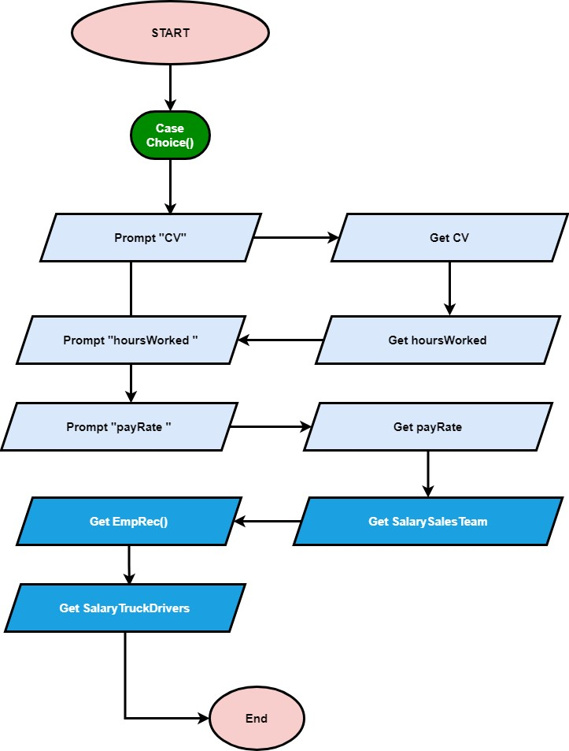

///function ensures applicant details are valid//

EmpRec(){

IF (CV=eligible) THEN{

Display”This CV is valid for processing”

ELSIF (CV=noteligible)THEN{

Display “This CV is invalid for processing ”

Return EmpRec

End Function

}

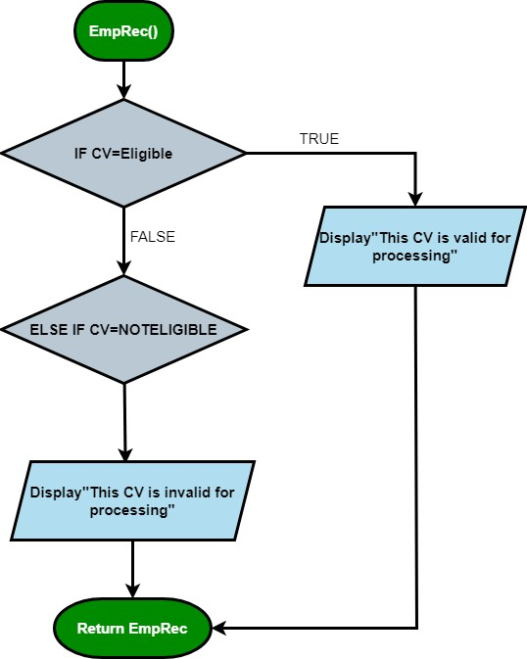

SalarySalesTeam(){

IF (hrsWorked=15) AND (baseSalary=70) THEN {

Calculate sales payRate

Salary = (payRate* hrsWorked)

ELSE

IF (overtimeHrs=7) THEN { Calculate overtimepay overtimePay=hrsWorked * payRate monthly sales Teamsalary=(baseSalary * 15) + overtime hrs

} SalaryTruckDrivers(){

Calculate employeeSalary

Read employee details

IF employee bank details=”valid” THEN {

Calculate employeeSalary

Salary= hrsWorked * payRate) + overtime hrsWorked

ELSEIF

Employee bank details= “invalid” THEN {

Display “cannot calculate employee salary”

Return TruckDrivers salary

}

End Function

}

END module

}

